SMS Spam message detection

Executive Summary

## Presented by

Jed Chang

1. Summary

The goal is to create a machine learning model that can automatically detect and filter spam emails from a user's inbox, improving email management and reducing the risk of falling victim to phishing or fraudulent messages. The project involves implementing natural language processing (NLP) techniques, such as text classification and sentiment analysis, to train machine learning models capable of accurately identifying spam emails.

1. Methodology

Process:

1. Gather Data from kaggle
2. Text Processing

getting data

replacing brackets from text with blank space

url removing from text data

removing words starts with @

row html removing

removing non character and non number data

word lowering

word tokenization

white spaces removing

stopwords removing

lemmatization / stemming

1. Brainstorm metrics to measure model accuracy
2. Create a vanilla model
3. Compared BernoulliNB and LogisticRegression
4. Testing the model we create
5. Use metrics to determine our final model

Due to spam messages are less than non-spam messages (see in Figure1), I decided to use other two datasets, and concatenate them to imbalance dataset handling.

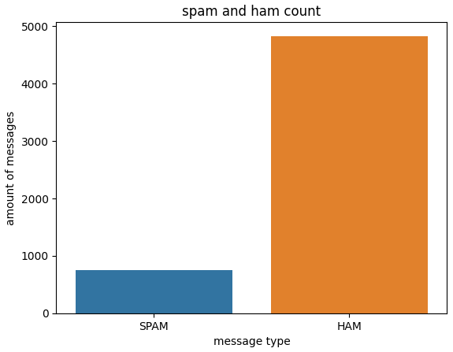

Figure 1

1. Results, Action Items, and Limitations

|  |  |  |  |  |
| --- | --- | --- | --- | --- |
|  | BOW(BernoulliNB) | tf-idf(BernoulliNB) | BOW(Logistic Regression) | tf-idf(Logistic Regression) |
| Score | 84.3% | 84.3% | 94.8% | 92.1% |

(Table 1)

Based on these results, the BOW with Logistic Regression model has the best performance. This demonstrates a promising future for spam message detection. The model can provide reasonably accurate estimates for determining what each message is spam.

Limitation: As technology is improving everyday, spam messages are also improving. Needs to update the newest spam message frequently fro training model use.

1. Python Notebooks

Below is Github Gist link to the notebook we used during this case study:

<https://colab.research.google.com/drive/189zvJZY-W4i_scCo-0QNMgqjkbc4zeNK#scrollTo=6VcHe6xCUKZK>

Categories: 4 All requirements were met.